**Ekezakenya: A Web-based Platform to Connect Investors to Entrepreneurs in Search of Funding**

Gikunju Dennis Mwangi

102727

Submitted in partial fulfillment of the requirements of the Bachelor of Business in Information Technology at Strathmore University

School of Computing and Engineering Sciences

Strathmore University

Nairobi, Kenya

2022

Declaration and Approval

I declare that this work has not been previously submitted and approved for the award of a degree by this or any other University. To the best of my knowledge and belief, the research contains no material previously published or written by another person except where due reference is made in the research itself.

Student Name: Gikunju Dennis Mwangi

Admission Number: 102727

Student Signature: _____________________________

Date: ________________________

Supervisor Name: Mr. Tiberius Tabulu

Supervisor Signature: _____________________________

Date: ________________________

Abstract

In Kenya, the odds of getting funding for a start-up are against the entrepreneur’s favor regardless of the resources put into sourcing the funds. The disconnect between investors and entrepreneurs hinders business growth, which at times leads to premature business failure during the ideation stage.

However, the world has become a global village where people are interconnected over the internet. Getting an investor is no longer limited to a specific geographic location. Despite this convenience, entrepreneurs need to put in the work to be at the right place and be seen by the right people. An online presence is insufficient in guaranteeing an investment opportunity or audience with a potential investor.

Thus, the solution is a web-based platform that aims to bridge the gap between entrepreneurs and investors in Kenya. It automates processes that may be cumbersome, such as searching for investors and mentors while considering the clients’ credentials and data security. Hence, the solution creates a platform where entrepreneurs in search of funding can lay out their business proposals or plans to an audience of potential investors and mentors. Automation has both advantages and disadvantages. One of the drawbacks is the security and theft of intellectual property.

This system employs the prototyping methodology for its development. This is a methodology in which a prototype is built, tested, and then reworked as necessary until an acceptable outcome is achieved from which the complete system or product can be developed. The choice to use the Prototyping methodology is flexible in design and it is easy to detect errors during the development or improvement of the system. It is also easy to find missing functionality within the system. There is scope for refinement, which means new requirements can be easily accommodated. Prototyping methodology gives scope for refinement, which in this case means new functionalities can be accommodated with ease whenever is a change or development in the user requirements.

Table of Contents

Declaration and Approval ii

Abstract iii

Table of Contents iv

List of Figures vii

List of Abbreviations viii

Chapter 1: Introduction 2

1.1 Background 2

1.2 Problem Statement 3

1.3 Objectives 4

1.3.1 General Objective 4

1.3.2 Specific Objectives 4

1.4 Research Questions 4

1.5 Justification 4

1.6 Scope and Limitations 5

Chapter 2: Literature Review 6

2.1 Introduction 6

2.2 Parameters Considered for Funding of Startup-ups by the Potential Investors 6

2.2.1 Feasible Business Plan 6

2.2.2 Market Traction 6

2.2.3 A Positive Return on Investment (ROI) 6

2.2.4 Clear Distribution of Investment 7

2.3 Challenges Faced by Start-ups in Search of Funding 7

2.4 Related Works 8

2.4.1 Angel Investment Network 8

2.4.2 Crunchbase 9

2.4.3 Industrial and Commercial Development Corporation (ICDC) 10

2.4.4 Kenya Industrial Estates Ltd 11

2.5 Gaps in Existing Systems 12

2.6 Conceptual Framework 13

Chapter 3: Methodology 14

3.1 Introduction 14

3.2 Development Approach 14

3.3 Project Methodology 14

3.4 Justification of the Methodology 14

3.5 Stages of Prototyping Development Life Cycle 15

3.5.1 Gathering and Analysis of Requirements 15

3.5.2 Quick Design of the Prototype 15

3.5.3 Creating a Prototype 16

3.5.4 Initial Evaluation by the User 16

3.5.5 Prototype Refinement 17

3.5.6 Implementation 17

3.6 System Analysis 17

3.6.1 Use case Diagram 17

3.6.2 Sequence Diagram 17

3.6.3 Entity Relationship Diagram 18

3.6.4 Database Schema 18

3.7 System Design 18

3.8 Testing 18

3.8.1 Black Box Testing 18

3.9 Project Deliverables 18

3.9.1 Admin Module 18

3.9.2 Investor Module 19

3.9.3 Entrepreneur module 19

3.9.4 Signup and Login Model 19

3.9.5 Profile Module 20

Chapter 4: System Analysis and Design 21

4.1 Introduction 21

4.2 System Requirements 21

4.2.1 Functional Requirements 21

4.2.2 Non-Functional Requirements 22

4.2.3 Functional Requirements 23

4.2.4 System Analysis Diagrams 23

4.2.5 System Design Diagrams 24

Chapter 5: SYSTEM IMPLEMENTATION AND TESTING 28

5.1 Introduction 28

5.2 Description of the Implementation Environment 28

5.2.1 Hardware Specification 28

5.2.2 Software Specification 28

5.3 Description of Testing 29

5.3.1 Black box Testing 29

5.3.2 Testing Results 29

Chapter 6: Conclusions, Recommendations and Future Works 31

6.1 Introduction 31

6.2 Conclusions 31

6.3 Recommendations 31

6.4 Future Works 31

References 32

Appendix: Gantt Chart 35

List of Figures

Figure 2.1: A visual representation of what the Angel Investment Network website offers to entrepreneurs. 9

Figure 2.2: An illustration of services offered to entrepreneurs by Crunchbase. 10

Figure 2.3: An image depicting some of the services offered by ICDC (Kenyan organization) to entrepreneurs in search of funding 11

Figure 2.4: An illustration of products and services offered by Kenya Industrial Estates 12

Figure 2.5: Conceptual framework illustrating parameter considerations for seed funding. 13

Figure 3.1: An illustration of the six SDLC phases of the prototyping model. 15

List of Abbreviations

SEO – Search Engine Optimization

OOAD – Object-Oriented Analysis and Design Methodology

JWT – JSON Web Tokens

FDI - Foreign Direct Investment

# Introduction

## Background

Businesses require funds at each stage of their life cycle. The business life cycle is the progression of a business that comprises product development (seed), market introduction, growth, maturity, and finally, decline or exit. Start-ups are stagnant in the early stages of product development and market introduction. As an excellent form of entrepreneurship, they represent a vibrant economy with an appetite for risk and a vision for addressing and solving societal issues (Shaikh, 2019). Moreover, they offer innovative solutions to old-age as well as new challenges. It is therefore imperative to support start-ups in their infancy. At this stage, acquiring funds is fundamental in ensuring potential success. Despite having a great business idea, implementation requires specific financial and material resources.

Every year, thousands of people enter the world market with unique ideas, aiming to acquire a piece of the global market and make their firm the next big thing. Capital is a crucial component in seizing business opportunities. Entrepreneurs often provide seed capital themselves or actualize it through contributions from family and friends. At times, the scale of financing needed to take a business to the next level exceeds the scale of personal resources. Raising financial capital through angel investors, crowdfunding, and venture capitalists are among the top ways of realizing seed or start-up capital when access to credit poses a challenge. However, it is hard to find investors during the infant stages of a business as seed investments are considered very high-risk (Subramanian & Taghizadeh-Hesary, 2021). Investors are attracted by the ability to scale with minimal expenditures.

Technology’s impact on everyday life is far-reaching. It has also had a beneficial impact on entrepreneurship (Drake, Fabozzi & Fabozzi, 2022). As the internet has become more accessible, innovators have come up with new solutions to challenges in various fields. Entrepreneurs and investors, for instance, can gain easy access to vast, reliable information on capital funding and investment opportunities with the internet. Additionally, efforts to secure funding require less time. Currently, there exist crowdfunding platforms online that offer equity funding. The idea is to raise the necessary capital funds by acquiring sizeable contributions from many investors.

Funding is critical for establishing the infrastructure needed for a start-up. A start-up can either thrive or fail in the market, depending on the country’s economic situation. Credit availability, resource availability, product and service demand, and overall economic conditions are some dynamic aspects to consider (Shaikh, 2019). Certain governments have laws that offer cash for start-ups, encouraging many entrepreneurs to pursue their dreams (Shaikh, 2019). According to a poll conducted by the British Council, the most significant hurdle to start-ups in Kenya is access to grant funding (British Council, 2022).

There is a limited capacity for managing funds available to support entrepreneurship in Africa. Further, entrepreneurs considered access to capital as a significant impediment to growth in the abovementioned poll (British Council, 2022). Financial markets in emerging economies, such as Kenya, are often rudimentary. In turn, securing money for business start-up capital becomes more difficult. Excessive depreciation and inflation rates are often a great concern.

Entrepreneurship and new venture creation often involve a great deal of risk and personal sacrifice. Capital funds are crucial for business growth and guaranteeing the success of early-stage business start-ups. Acquisition and pursuit of such resources is quite the task. Government policies and regulations, for instance, could hinder efforts aimed at acquiring funding as some incentives discourage people from starting businesses or supporting start-ups (Shaikh, 2019). Technology can be instrumental in easing the process of procuring capital. Therefore, a web-based platform for connecting investors with entrepreneurs searching for funding bridges the gap where local entrepreneurs lack the right avenues to pitch their ideas to potential investors and also where the investors lack the means to identify the right investment opportunities.

## Problem Statement

There is a chasm between investors and start-ups searching for funding. Some investors lack the means to identify the right investment opportunities (Startupbootcamp, 2014). Moreover, the appropriate forums or platforms to pitch ideas are unknown to some entrepreneurs despite having great creative and innovative ideas. Additionally, most entrepreneurs do not have avenues to access capital and in most cases, if an entrepreneur is lucky enough to get capital it is mostly because whom they know rather than what they know.

As a result of the problem mentioned above, the project aims to connect investors and entrepreneurs seeking investment opportunities and funding respectively by creating a platform where entrepreneurs can securely present their ideas or proposals to an audience of investors, and the interested investor can take it up with the entrepreneur by providing funding or even mentorship. By providing a secure dedicated platform for connecting entrepreneurs with investors, the process of procuring funding and investment opportunities is made easier. Further, investors will benefit from a more streamlined experience that aligns with their goals and interests.

## Objectives

### General Objective

The proposed platform aims to come up with a web-based platform that connects investors to entrepreneurs in search of funding.

### Specific Objectives

1. To review the parameters considered for funding of startup-ups by the potential investors
2. To investigate the challenges faced by start-ups in search of funding
3. To review existing platforms that link investors to entrepreneurs and their challenges
4. To develop a web-based platform that links investors to entrepreneurs in search of funding
5. To test the system

## Research Questions

1. What factors are taken into account when a investors support startup in need of funds?
2. What are the challenges start- face when sourcing fonds?
3. What are the existing platforms and what are the gaps in the existing systems?
4. How can a web-based platform that connects investors to entrepreneurs in search of funding be developed?
5. What types of testing will the system undergo?

## Justification

Start-ups play an essential economic role in economic growth (Shaikh, 2019). They create employment opportunities and promote economic development, growth, and stability (Robert C. Dent, May 2016). They also play a part in encouraging innovation and instilling competition in the world markets. In addition, they encourage research and innovation. Start-ups transform societal values and instill proactivity. However, studies show that most start-ups collapse within the first decade of operation. Research suggests that the main reason for the collapse is the failure to predict internal and external risk factors, which could influence the success potential of start-ups. Start-up financing effectively safeguards against such risks, preventing start-up failure (Robert C. Dent, May 2016)

A start-up might require funding for various reasons such as prototype creation, product development, team hiring, working capital, marketing and sales, and asset acquisition, among others. Equity financing is one approach start-ups take to acquire funding (Shaikh, 2019). Angel investors and venture capitalists invest their money into high-potential start-ups in return for equity. Acquiring seed money and identifying high-potential start-ups for entrepreneurs and investors can be pretty burdensome. Most people do not fully realize what they are getting themselves into when they take their initial step into entrepreneurship.

The system bridges the divide between start-ups and investors by providing a secure platform to connect investors with business start-ups. Start-ups will have a platform to maintain and showcase their profile, find investors that match their idea and currntcurrentopment phase, and get feedback and advice for accelerating progress. On the other hand, investors will have access to innovative investments matching their particular interests, create and use scorecards for evaluating start-up profiles, and connect with investor communities. All start-ups should be able to connect with investor communities without attending a conference or taking a master class course that may leave them empty-handed. The system aims to help start-up businesses grow and expand by offering reliable support to all those involved in equity funding.

## Scope and Limitations

The scope of the system is start-ups within Kenya. The system with proper development and expansion may be able to serve other regions within Africa and the rest of the world. The platform will be made up of different modules that will be used to manage the different functionalities. The modules include an admin module, user module, sign-up, and sign-in module, and finally a payment module.

The admin module enables management of the system and activities occurring within the platform. There is also a user module that enables users of the system (investors and entrepreneurs) set up their profiles. There is also a signup and sign-in module that facilitates regitreginnnnnnnnaccess of thtosystem funcafacilitiesoth the investors and entrepreneurs. Lastly, aent magente that itates the transfer of funds from the investors to the entrepreneurs via the platform.

# Literature Review

## Introduction

This chapter reviews the literature on investment, patterns, and market trends. It will give a clear picture of the startup landscape in Kenya. The problem under study will be to develop an interactive platform that will enable entrepreneurs and investors to interact.

## Parameters Considered for Funding of Startup-ups by the Potential Investors

Start-up investors look for specific cues to persuade them to part with their money. Startups must understand how to attract and target the right set of investors to gain funding. Some of the critical elements investors look for when making an investment decision include:

### Feasible Business Plan

Investors want to see a good, well-thought-out, clear, and comprehensive business plan. They want to know that the entrepreneur is not unduly optimistic and is, at the very least, realistic about the future of their company. They also want to know that entrepreneurs have a vision for their business and a strategy for achieving their objectives.

Investors will look for financial predictions, extensive marketing plans, and information about the entrepreneurs' target market in the business plan. Entrepreneurs must have a good business plan. (Richards, 2021).

### Market Traction

The majority of investors seek business opportunities with room for expansion. Depending on the nature of an entrepreneur's product, the company must have a substantial market reach, at least regionally. If the entrepreneur sells boats, they have only a localized market along the shoreline and lakes, but given the total market for boats, it may be adequate. Like the Samsung phones, not every product will have a global market. However, to attract investors, a large enough market in which economies of scale may be implemented into a startup's operations to improve margins and profits will be required (Bradshaw D., 2010).

### A Positive Return on Investment (ROI)

Angel and venture capital investments are frequently motivated by a desire to assist entrepreneurs in sustaining their business, but the prospect of generating income is also appealing. Analyzing the probable return on investment (ROI) associated with a specific start-up is essential for investors looking to gain high returns on equity. The type of investment determines returns.

A high expected rate of return on investment influences venture capitalists to take on more risk. Equity financing is a high-risk investment method, and because a start-up is still in its early stages, determining an average rate of return is challenging (Lake).

### Clear Distribution of Investment

Purchasing stock in a company has legal implications, and investors will want to know that an entrepreneur has thought about these concerns. The entrepreneur will need to set up a business structure that will allow other parties to invest. The entrepreneur must also have a clear plan for how the investment will function.

Part of this entails having a precise startup valuation as a strategy to back up the entrepreneur's request for a specific amount of money in exchange for a given amount of ownership. If an entrepreneur asks a certain amount of money for a certain percentage stake in their company, for example, he or she must be able to demonstrate that the company is genuinely worth a certain amount of money.

Further, it entails drafting a stockholder's agreement that clearly defines the rights of all owners. This agreement should cover the rights and obligations of the owners, what happens if one owner wishes to sell, what happens if leadership changes, and what happens if the business closes, among other topics. If the entrepreneur intends to provide dividends, he or she must determine how much, how frequently, and what will happen if he or she cannot make a distribution. This particular section is likely to involve some negotiations. Startup investors may seek a more significant share at a lower price and changes or additions to the stockholder's agreement. At this stage, an entrepreneur should get legal advice. It would be devastating to have a startup grow into a profitable firm, only to discover that the entrepreneur has lost control of their business to investors.

## Challenges Faced by Start-ups in Search of Funding

Small informal businesses account for the vast majority of all enterprises in low and middle-income countries. The informal sector employs 82.7 percent of the workforce (FSD Kenya, 2017). With such a large number of informal businesses, it is only natural that more resources and a more accommodating environment be directed toward them. Even if it goes unnoticed, these businesses collectively contribute significantly to the economy. This research focuses on creating a stable platform through which the efforts of these small and informal businesses will be acknowledged and appreciated.

Despite the fundamental role SMEs play in the Kenyan economy, these enterprises cannot attain optimal levels of operation due to various challenges. Due to conditions like collateral for the loan, these businesses lack access to credit and finance, particularly from financial organizations such as commercial banks. Additionally, they may fail to provide collateral due to their small asset base. Similarly, the lack of knowledge such as managerial skills and exposure is a significant challenge since most strategies are executed through trial-and-error mechanisms (David, Gopalan, & Ramachandran, 2021).

Another major setback is rapid technology changes which the enterprises may not be able to adopt due to their high initial and installation costs (Kaaa, 2017). These are but a few of the challenges that these businesses face. It gets even more challenging for them with the kind of legislation put in place by the government that may be favorable for businesses in their life cycle's growth or maturation stages but is too stringent for those in their early stages (David, Gopalan, & Ramachandran, 2021). Through this research, most of the challenges will be addressed in advance, and the workload will be reduced. For example, small business owners will get a chance to enhance their managerial skills through guidance from investors with vast experience.

## Related Works

### Angel Investment Network

Angel Investment Network is a web-based platform that brings together businesses looking for investment and angel investors with the capital, contacts, and knowledge to help them succeed. It has a well-laid-out structure to ease the interaction of the users with the platform as illustrated in figure 2.1. One can create an account based on their interests, i.e., as an entrepreneur seeking funding or an investor.

The stumbling block of this system is that it only consists of angel investors, and as a result, the platform is not suitable for anyone seeking an investment of less than $25,000 or more than $100,000. The amount may, however, vary depending on prevailing circumstances.

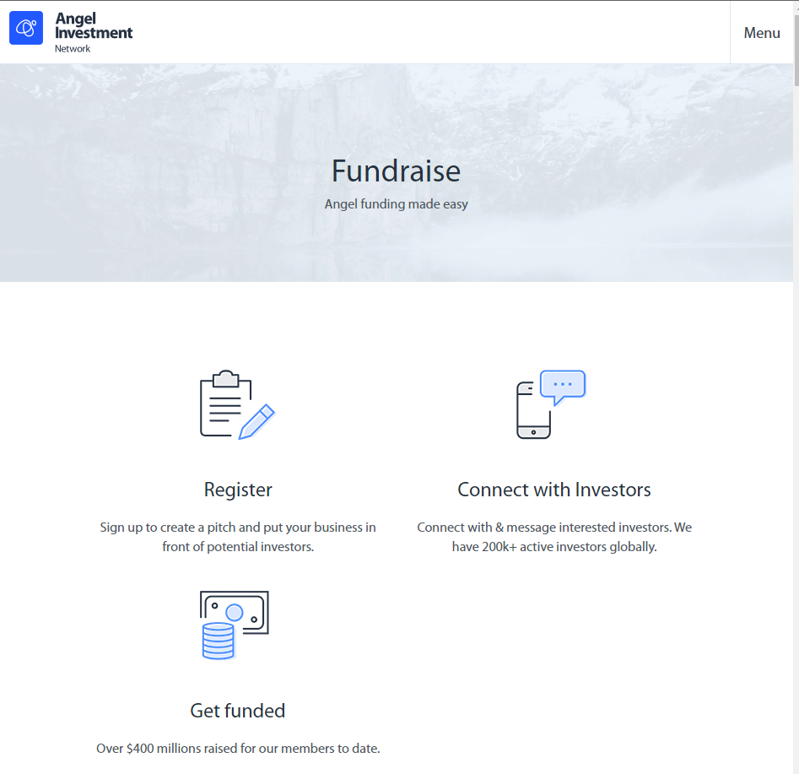

Figure 2.1: A visual representation of what the Angel Investment Network website offers to entrepreneurs.

### Crunchbase

Crunchbase is the leading platform where investors get to connect with entrepreneurs globally. It comprises over 55 million professionals from various industries. It attracts enormous traffic annually, both from individual entities and companies. Aside from having professionals, it is composed of data insights on investments and market trends to guide its clientele in making the right investment decisions. Albeit the numerous benefits the platform prides itself on, there is a notable downside to the visual complexity. The placement of the attributes on the dashboard is not appealing, as seen in figure 2.2, in which a minimalistic approach would be fitting for a web application like this one.

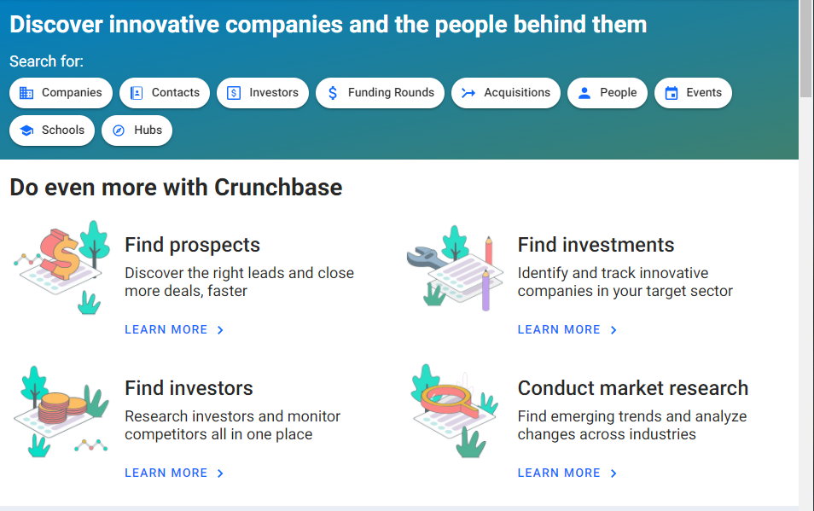

Figure 2.2: An illustration of services offered to entrepreneurs by Crunchbase.

### Industrial and Commercial Development Corporation (ICDC)

ICDC promotes projects that create wealth and jobs for Kenyans in diverse sectors of the economy. It offers businesses options from which to acquire revenue, the majority being loans, depending on the business needs as shown in figure 2.3. It has a keen interest in the manufacturing, agro-processing, energy, ICT, infrastructure, financial services, and education sectors. The limitation of this system is that it is the sole investor; thus, it is inclined to invest in particular projects at the expense of others.

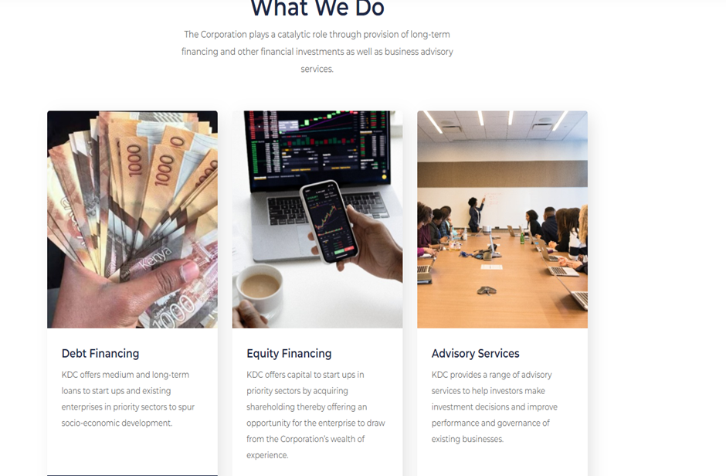

Figure 2.3: An image depicting some of the serces offeservices ICDC a (Kenyanrganization) to entrepreneurs in search of funding

### Kenya Industrial Estates Ltd

KIE was established as a subsidiary of ICDC with a major role in promoting indigenous entrepreneurship by financing and developing small-scale and micro-enterprises. It facilitates the development of micro, small and medium enterprises (MSMEs) countrywide by setting up industrial parks providing business development services and credit sustainably. The only notable downside of this system, depicted in figure 2.4, is that the organization is the sole investor and only focuses on MSMEs.

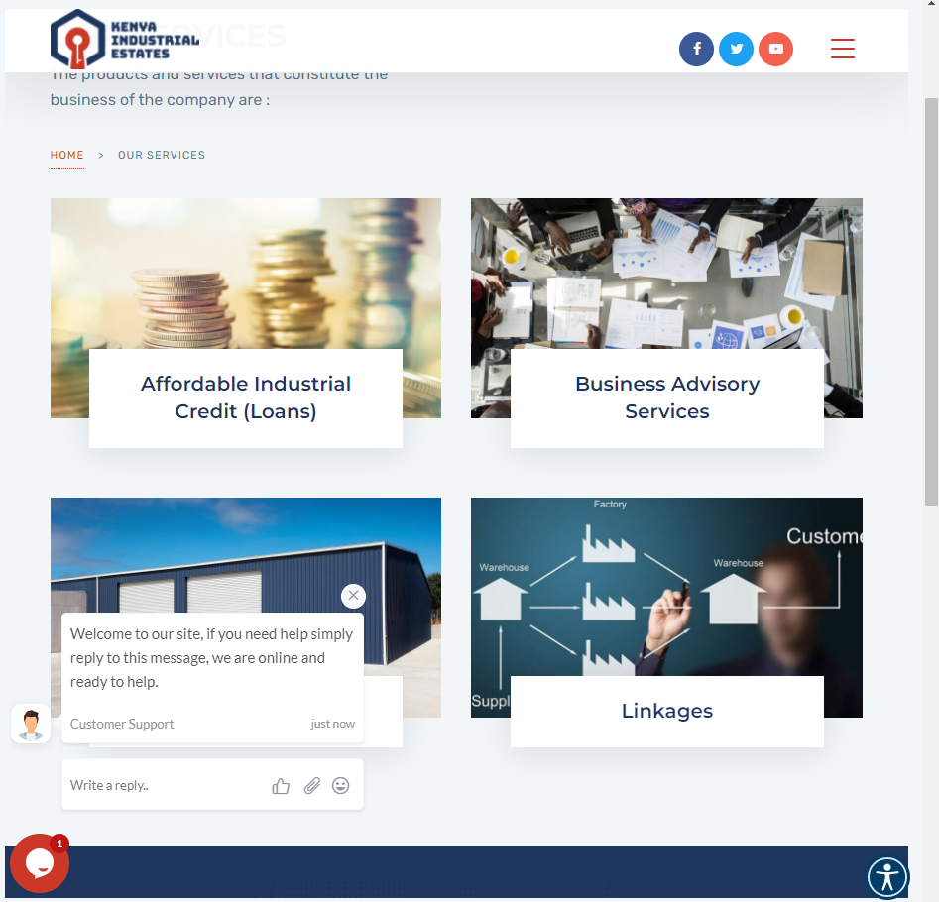

Figure 2.4: An illustration of products and services offered by Kenya Industrial Estates

## Gaps in Existing Systems

Although they offer several benefits, the systems lack in some areas. Initially, only a few systems are focused purely on the local market. Despite being of a significant impact, most online platforms spread their service worldwide, creating a threshold to which they can understand the business scene in member countries. Nonetheless, those that are Kenyan-based are owned by companies and organizations that are the only investors on their platforms, some of which only invest in select sectors. This exclusivity leaves Kenyans willing and capable of investing with the challenging task of searching for the right businesses aligned with their goals and interests to offer funding and other resources.

## Conceptual Framework

A conceptual framework illustrates the findings expected through research. It defines the relevant variables for this research and maps out how they might relate to each other. Figure 2.5 below is the conceptual framework diagram for this research. It illustrates the parameters both start-ups and investors should consider when searching for funding and investment opportunities.

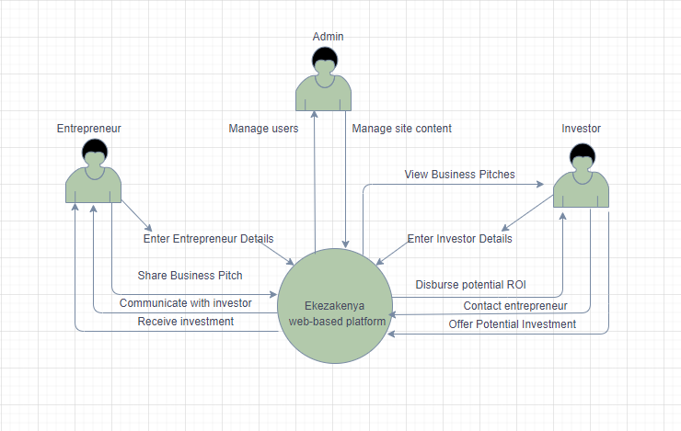

Figure 2.5: Conceptual framework illustrating parameter considerations for seed funding.

# Methodology

## Introduction

This chapter focuses on the methodology employed in the system's development. The system's requirements, such as functional and non-functional requirements, are also defined to comprehend the system's development process. This chapter goes into detail on what the system delivers and the tools and procedures required to make it happen.

## Development Approach

The OOAD technique is the best way to create a web-based application. OOAD makes development simple. reuseD, code re-use decrreuseinstances of spaghetti code, keeping the code tidy and readable for debugging. It represents real-world objects and entities, allowing for a clear comprehension of the design process (Half, 2021).

## Project Methodology

The development of the web-based platform employs the use of prototyping methodology. This is a methodology in which a mock-up or demo of what the platform will look like is built. Prototyping is an iterative methodology that allows the participation of the users and regular updates to the application as the building continues to occur.

## Justification of the Methodology

The creation of a prototype allows the project stakeholders to see what the final product will look like early in the project life cycle. There are quite a several reasons to do this: to gain agreement on what is in and out of scope, to test theories and ideas regarding the layout and structure of the web-based platform, and most importantly to gather feedback through usability testing. Normally a web-application prototype will go through a few rounds of usability testing where it is constantly reworked until it meets the set objective (Brian, 2021).

The prototyping methodology is flexible. It can be easily changed and modified according to the preferences and needs of the customer or the developer. Furthermore, the developer can reuse the prototype for future use in more complicated projects. A prototype improves the ability to detect errors in the initial stages of the project. As a result, the inclusive cost and time of the project are reduced. Prototype models enable the developer to foresee the areas of expenditure that were not taken into consideration beforehand. It addresses the changes needed in the project before the adjustment process becomes expensive (Prasanna, 2022).

In this methodology the users are involved actively in the development phase and, thus, it is easier to develop the model according to their preferences. Since the users are actively involved, errors are detected in the preliminary stages, making the process easier. Since the customer has direct interaction with the prototype model, their feedback is much faster. These feedbacks are essential since they are taken into consideration while creating the final system. The customers can quickly provide their thoughts, report the changes required in the project, and then the developers can modify the project accordingly (Prasanna, 2022).

## Stages of Prototyping Development Life Cycle

There are several stages in the process of prototype product development. The main stages are explained below with how they are going to be applied in the proposed web-based platform.

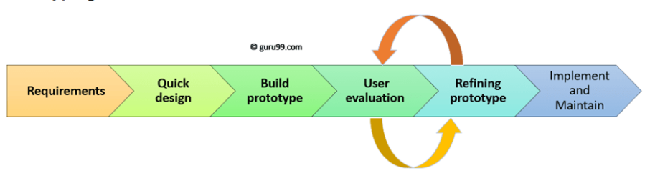

Figure 3.1: An illustration of the six SDLC phases of the prototyping model.

.

### Gathering and Analysis of Requirements

The following methods will be used to obtain functional and non-functional requirements.

#### Reviewing Existing Documentation

Reviewing documentation on existing systems like user manuals and instructions helped derive requirements that may have been overlooked. It also helped in learning and understanding important information that pushes the boundary of establishing new requirements or validating the existing ones. Moreover, they also showed the best technology to use while implanting specific requirements.

### Quick Design of the Prototype

In this stage, a quick and simple design of the system was created. It focuses on those aspects which are visible to the user rather than the detailed plan. This was achieved by building on the important aspects of the system i.e. the input and output formatof the format ofso that users can get a feel of how the actual system will appear. abbreviating a version of the system that will perform limited subsets of functions. The quick design of the prototype was brought to lthe ife by of tools such as Visual Studio (Vscode), Cascading Style Sheet (CSS) for the appearance of the forms, Hypertext Markup Language (HTML) for the designing of the forms

### Creating a Prototype

In this stage, a small working model of the proposed solution of a web-based platform was created. The working model was created based on the gathered information from the quick design. The working model will more or less equal the actual or the final solution which is meant to be developed. The prototype was developed using the Objeriented Analysis and Design (OOAD) which and code reuse which keeps the code tidy and readable for debugging. Some of the tools and technologies used in the development of the prototype includethe :**includeeeee**n development of the prototype, this was used to structure and present content on the web. It was prefer WHwas pddddddddonMark, Whatwg and thWHATWG,s due to its compatibility with all new versions of web browsers.

1. **CSS3**

Similarly, the latest version of CSS was used to incorporate its mor,e advancemoresuperior and newer features in styling the system prototype.

1. **JavaScript**

JavaScript was used to enhance the instructiveness of the application. of main purpose for this was to enhance the user’s interaction with the system.

1. **React**

React is a JavaScript library that enables creation of interactive user interfaces. This framework was used for the development of the web application’s frontend so that there is efficient updating and rendering of the specific components when the data changes.

1. **NodeJS**

NodeJS was used to develop the backend of EkezaKenya web application because it cross-platform. It also uses an event-driven I/O model which makes it extremely efficient and easy to scale.

### Initial Evaluation by the User

The prototype was presented to the client for evaluation. This was done through crowd-based evaluation. The tester group examined the prototype on their own devices for user-friendliness and provided constructive feedback

### Prototype Refinement

In this stage, the working prototype of the web application was refined according to user feedback collected in the initial evaluation by the test users on design, usability and user experience. With feedback from test users in mind, we could not completely prevent scope creep.

The best way to minimize the scope creep was to define the requirements upfront as thoroughly as possible. Prototyping sessions between the test users and the developer at an early stage mitigated scope creeps. This stage was considered to be complete once feedback from them had been addressed and met. Then lastly, the web application was developed.

### Implementation

The final system was developed according to the final working prototype of the solution and this was tested thoroughly and deployed. This developed solution was to be under maintenance to prevent downtime and large-scale failures.

## System Analysis

After the requirements are gathered and the data is recorded, the data will be categorized further, and this will allow the return of results that are related to the study. System analysis is a problem-solving technique that decomposes a system into its component pieces to study how well those parts work and interact to accomplish their purpose. Some of the diagrams that will be used in the analysis of the proposed solution will include a use case and sequence diagram, entity relationship diagram database schema, and a class diagram.

### Use case Diagram

Use case is a diagram that models the behavior of a system and allows a developer to capture the requirements of a system. In the proposed system, the use case diagram will be used to identify interactions between the proposed system and its users.

### Sequence Diagram

A sequence diagram is a type of interaction diagram that describes how groups of objects work together. In the proposed solution, this diagram will be used to depict the objects involved in the sequence of messages exchanged between objects that are required for the functionality of action and the action itself.

### Entity Relationship Diagram

This is a relationship diagram that shows the relationships of entities that are stored in the database. In the system, the entities are placed in a manner that they show interrelation with each other and therefore show related outputs once keyed in.

### Database Schema

In the system, the database schema is a skeletal representation of the web-based platform’s database, showing how data is organized and related to each other within the system.

## System Design

This is the process that will define the components, modules, interfaces, and data for the system to satisfy specified requirements. For the proposed solution, the system design will be done using logical schemas

## Testing

### Black Box Testing

Black box testing involves testing a system with no prior knowledge of its internal workings. A tester provides an input, and observes the output generated by the system under test. Both functional and non-functional requirements will be tested. Functional requirements were monitored by testing specific functions or features of the software under test. Non-function requirements were monitored by observing how the system performed specific actions.

## Project Deliverables

A deliverable refers to a tangible or an intangible service because of a project that is intended to be delivered to a customer. The deliverables of our system project shall include a use case diagram to show how the system operates. A Gantt chart to show how our work will be scheduled shall also be available. In addition, we shall have a documented manual, a source code, and a website to access our web application.

### Admin Module

The admin is the most powerful user of the system and manages the users of the system and their transactions without questions as per the laid-out policies. The system will have only one admin. The admin will be able to carry out the following actions: The admin can create, manage or delete any of the other two user accounts. The admin can monitor all activities on the system. If any of the users violates any of the policies, the admin will take action as per the violation.

### Investor Module

This is the user who is willing and ready to invest money in another person’s business in exchange for equity in the business. This user can pick any number of businesses to their liking. They have privileges such as viewing the entrepreneurs’ profiles incognito as they scout for what suits them best. Upon identification of the venture, they will reach out to the business owner seeking additional details or seal a deal. The user could have varying privileges as well depending on the subscription they have; either as an angel investor or venture capitalist. They, later on, transfer funds via a secure channel to the new partner, and the status of their partnership is indicated on their account.

### Entrepreneur module

This is the user who seeks funding to grow their business. They too can view the various investors available provided they have kept their accounts public otherwise they will have limited access to certain accounts. The user could as well set up a premium account which will grant them access to every detail unlike those on a basic plan. Upon deep conversations and agreements which lead to a partnership; the entrepreneur will receive the funds from the investor via the same secure channel. The entrepreneur is tasked to frequently update the investor on how the business is fairing and liaise with them on important decisions to be made.

### Signup and Login Model

Both the investor and entrepreneur will go through the initial phase which is signing up to interact with the system fully.

The registration will be the same for both users but via different panels, depending on the type of user they are joining as. The following are the common requirement fields: Full name, where the user will be required to key in their full name i.e., first name, middle name, and last name. Email, where the user will provide an email to be used for communication purposes and authentication during login. Password where the user will create a secure password that will enable them to set up and access an account.

When the user enters all the above details in their respective forms, they should read through the terms, conditions, and policy. If they are satisfied with everything, they should tick the checkbox and click on the create account button.

When the registration process is completed successfully, a mail will be sent to the email address provided for verification purposes. After following and executing the steps provided, the user will be redirected to the login page.

After registration and successful verification, the user will be required to use their email and password to log in to the system. If both values match those in the system, the user will be granted access. For every type of user, there will be a different view and privileges of the system. Measures will already be in place just in case the user forgets their credentials due to one reason or the other. They will be able to reset their credentials via email, where users will just key in the email affiliated to the system, through which they’ll receive a prompt to reset their details. Mobile, is similar to the reset via email, only that the reset prompt is sent to the number provided on the profile.

### Profile Module

Upon successful login for the first time, the new user will immediately be directed to a profile page where they will be mandated to provide the additional information needed to fully set up their accounts. The details can be edited and updated accordingly at a later date. The following are the additional details needed: date of birth, gender, contacts, address i.e., the street, city, state, postal code and country, profile image, business credentials as per the user type.

# System Analysis and Design

## Introduction

This chapter decomposes a system into its component pieces for the purpose of studying how well those components work and interact to accomplish their purpose. A system analysis is conducted for the purpose of studying a system or its parts in order to identify its objectives.

The system analysis includes four activities: requirement modelling data and process modelling object modelling transition to system design.

## System Requirements

Requirement analysis is the process of defining the user expectations for an application that is to be built or modified. It involves all the tasks that are conducted to identify the needs of different stakeholders. Therefore, requirement analysis means to analyze, document, validate and manage software or system requirements. High-quality requirements are specific, measurable, actionable, traceable, testable, helps to identify opportunities, and are defined to facilitate system design.

### Functional Requirements

These are needs related to the technical functionality of the system. They state how the users will interact with the application, so the application must be able to comply and be testable. They describe how the system must behave, its features and functions.

The application will be made up of various sections to ensure all user requirements are met efficiently. This will include a login and signup section, an admin section, user dashboards and user profile cards which will act as posts.

1. **Registration**

New users provide their personal details such as email. As they provide the details the form validates the details on touch. The sign in button is rendered inactive until the user fills all the data appropriately. Once the data validation evaluates to true the data is passed to the backend where the passwords are hashed and salted, a session created and token passed to the front end.

1. **Log In**

A registered user uses their email and password to access the application. The email and password fields have form validation on touch for front-end error handling. Furthermore, on log in a session is created and a token passed from the backend to the front-end.

1. **Log Out**

On logging out the session is destroyed, and the user is redirected to the login screen.

### Non-Functional Requirements

Non-functional requirements specify criteria that can be used to judge the operation of a system in particular. These are conditions rather than specific behaviors. While functional requirements define what a system is supposed to do, non-functional requirements define how a system is supposed to be. Non-functional requirements can be termed as the quality attributes of a system.

The non-functional requirements of the web-based platform include:

1. **Confidentiality**

Sensitive data such as passwords will be salted and hashed to protect them be achieved by hashing passwords using bcrypt. This means that the owner is the only person who will know the passwords set and gain access to his/her data.

1. **Authorization**

Once the users are logged in, each subsequent request includes a JSON Web Token which allows the user to access routes, services and resources that are permitted with that token. Users’ data is transmitted and stored securely using JSON web tokens (JWT). The JWT are an open, industry standard method for representing claims securely between two parties.

1. **Usability**

The system is user-friendly and users should be able to use and navigate through it as instructions have been provided. This is achieved through simplistic user interface designs i.e. the screens are very simple and are not packed with lots of information in one place. Furthermore, the input fields are not blocked by the native device keyboard.

1. **Maintainability**

Maintenance of the web-based platform is relatively easy and can be categorized into time frames within which the maintenance should be done and specific activities to carry out under each time frame. The time frames include: weekly, monthly and quarterly. As the system was built using prototyping methodology, the system undergoes frequent reviews to meet the user’s needs. During these reviews the functionalities are retested to ensure they are working properly

1. **Availability**

The systems data is viewable by all users whenever they need to. This is made available as the system was developed using the 3-tier architecture model. If one tier fails than it only affects that tier and as it is being solved the other tiers may be accessible to the user

### Functional Requirements

These are system requirements that describe system behavior under specific conditions and include the product features and functions. The functional requirements of the web-based platform include:

### System Analysis Diagrams

#### Use Case Diagram

A use case diagram is a UML diagram that is used to summarize the details of the system’s users and their interactions with the system. Below is a use case diagram that illustrates the interaction of the users with Ekeza Kenya platform.

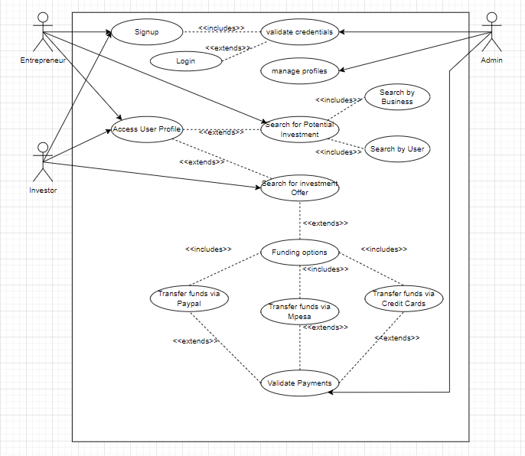

Figure 4.1: Use case diagram illustrating user interaction with the Ekezakenya system

#### Sequence Diagram

A sequence diagram or system sequence diagram shows process interactions arranged in time sequence in the field of software engineering.

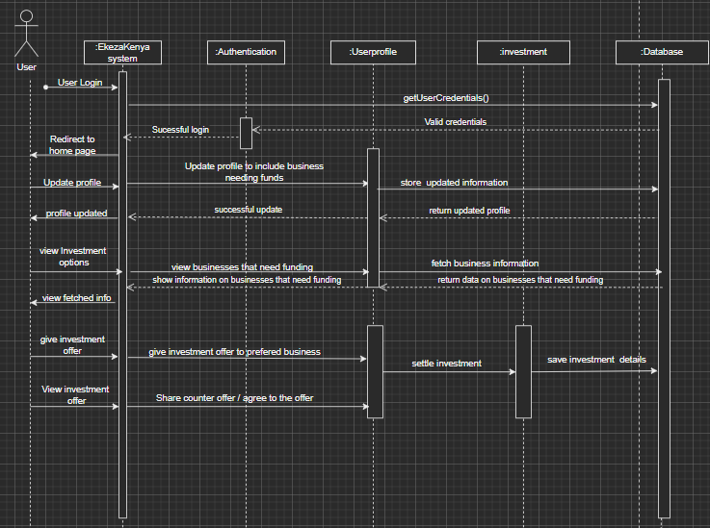

Figure 4.2: System sequence diagram shows process interactions within EkezaKenya system arranged in time sequence

### System Design Diagrams

#### Entity Relationship Diagram

An Entity Relationship (ER) Diagram is a type of flowchart that illustrates how “entities” such as people, objects or concepts relate to each other within a system. ER Diagrams are most often used to design or debug relational databases. Below is a logical database schema illustrating the database design of EkezaKenya.

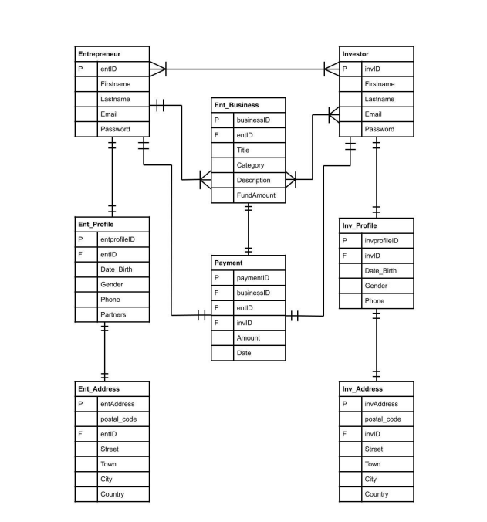Figure 4.3: Entity Relationship Diagram illustrating how entities within EkezaKenya relate.

#### Database Schema

A database schema is the skeleton structure that represents the logical view of the entire database. It defines how the data is organized and how the relations among them are associated. It formulates all the constraints that are to be applied on the data. Below is database schema that illustrates how data is organized within EkezaKenya’s relational database.

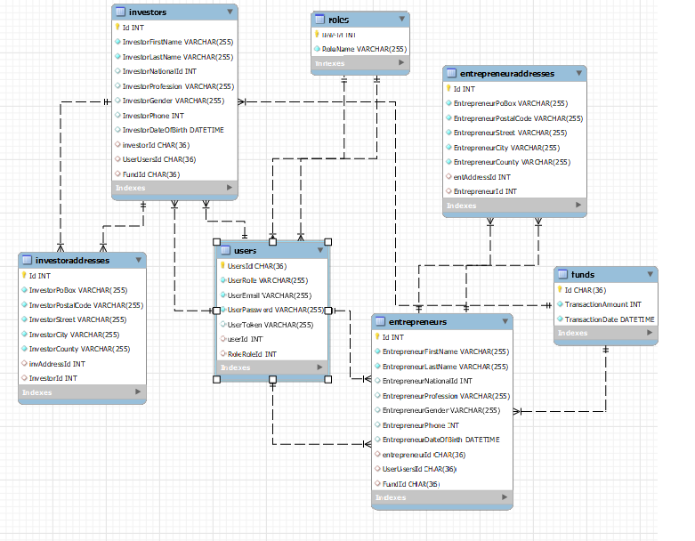

Figure 4.4: Database schema that illustrating how data is organized within EkezaKenya’s database

#### Class Diagram

Class diagram is a static diagram that describes the attributes and operations of a class and also the constraints imposed on the system. The class diagrams are widely used in the modeling of object-oriented systems because they are the only UML diagrams, which can be mapped directly with object-oriented languages.

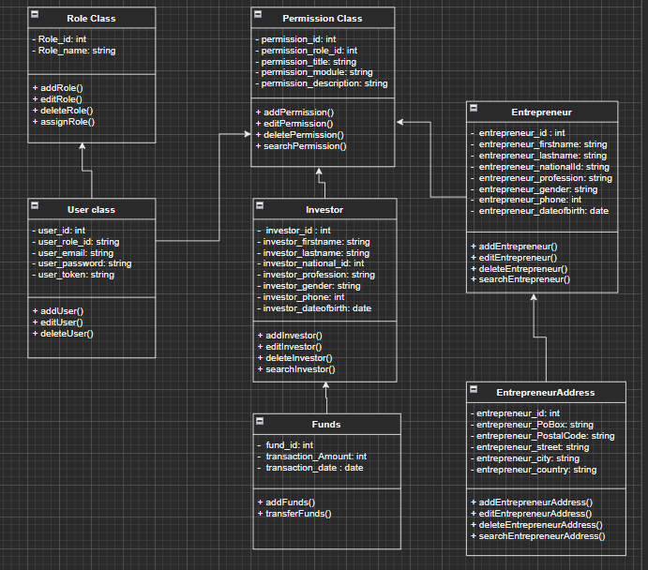

Figure 4.5: Class Diagram illustrating the attributes and operations of a class and also the constraints imposed on the system

# SYSTEM IMPLEMENTATION AND TESTING

## Introduction

System implementation is the process of defining how the information system should be built, ensuring that the information system is operational and used, and ensuring that the information system meets the quality standard System testing is a level software testing where a complete and integrated software is tested so as to evaluate the systems compliance with the specified requirements

In this chapter, the testing environment for this platform was discussed. The findings of the testing were also discussed.

## Description of the Implementation Environment

This section discussed the hardware and software specifications that were used to develop the malaria data visualization platform.

### Hardware Specification

1. **Laptop with a specification of 8GB RAM** – For the development of this platform, a laptop with a specification of 8GB RAM and 512GB SSD was used to ensure efficiency in the compilation of the code
2. **Operating system on the computer** – The operating system used for the development of this platform was the windows operating system.

### Software Specification

1. **Visual Studio Code (Vscode)**

Visual studio code is a code editor redefined and optimized for building and debugging modern web and cloud applications. Vscode was preferred over other code editors due to its built-in features and ability to work with other external plugins. Also, it has built in debuggers which make debugging much easier. It facilitates most of the actions carried out during development and thus increasing efficiency.

1. **MySQL Command-Line Client**

The MySQL Command-Line Client is an SQL shell with input line editing capabilities. It supports interactive and non-interactive use. When used interactively, query results are presented in an ASCII-table format. This tool was used because it was fast and simple to use. Once the MySQL server is up and running, the developer connects to the MySQL client as a super user.

## Description of Testing

This process involves evaluating and verifying that the software product implemented meets both functional and non-functional requirements.

### Black box Testing

Black box testing involves testing a system with no prior knowledge of its internal workings. A tester provides an input, and observes the output generated by the system under test. Both functional and non-functional requirements were tested. Functional requirements were monitored by testing specific functions or features of the software under test. Non-function requirements were monitored by observing how the system performed specific actions.

### Testing Results

|  |  |  |  |  |  |  |
| --- | --- | --- | --- | --- | --- | --- |
| Test case ID | Test scenario | Test step | Test data | Expectation | Output | Pass/Fail |
| T1 | Create a user with valid field data as investor | Fill all form field | Email: [dennisgikunju@gmail.com](mailto:dennisgikunju@gmail.com)  First name: Dennis  Last name: Gikunju  Pass: W945 r 425c  Confirm Pass: W945 r 425c | Redirect to login | Redirected to login | Pass |
| T2 | Create a user with valid field data as Entrepreneur | Fill all form field | Email: [dennisgikunju@gmail.com](mailto:dennisgikunju@gmail.com)  First name: Dennis  Last name: Gikunju  Pass: W945 r 425c  Confirm Pass: W945 r 425c |  |  |  |
| T3 |  |  |  |  |  |  |
| T4 |  |  |  |  |  |  |
| T5 |  |  |  |  |  |  |
| T6 |  |  |  |  |  |  |
|  |  |  |  |  |  |  |

# Conclusions, Recommendations and Future Works

## Introduction

This chapter examines the conclusions reached after the system's development and the recommendations that can be made regarding the system's use. It also emphasizes the system's future development that can be done.

## Conclusions

The Projects main objectives were to develop a web based application that connects local investors to entrepreneurs in search of funding. For this to be achieved, it was important to review other existing platforms that have been implemented in the past to gain a deeper understanding on how implement this system.

The system provides a platform for entrepreneurs to pitch their business ideas and proposals to a group of potential investors, after which the interested investor can schedule a virtual meeting with the entrepreneur to further discuss the business pitch. Furthermore, an entrepreneur can connect with other entrepreneurs to learn about what they are working on and even collaborate on something if they have similar or nearly similar ideas.

## Recommendations

To access services in this system, users of this platform must be connected to the internet. To ensure maximum efficiency, this platform should be accessed via computer rather than mobile device to ensure full access to all system features. Users are also advised to use Google Chrome, Firefox, Safari, and Microsoft Edge browsers, as these are the only web browsers supported by this system.

## Future Works

Given the time constraints and requirements, the system has been developed to its full potential. However, there are some changes that could be made to improve the current system, such as payment integration, because the business must be registered in order to access and use the payment APIs on this web application.

References

Associates, S. &. (May 25 2021). *Start-ups Requirements and Challenges.*

Bradshaw, D. (2010). Aligned for Success: A Guide to What Investors Look for in a Startup. *FinaNCE*, 1.

Bradshaw, D. (n.d.). *Aligned for Success: A Guide to What Investors Look for in a Startup.* Toptal.

Brian, L. (2021, August 30). *Top 5 Advantages of Prototype Model in Software Engineering that You Need to Know*. Retrieved from https://medium.datadriveninvestor.com/top-5-advantages-of-prototype-model-in-software-engineering-that-you-need-to-know-cfa0d119e3b0

da-14. (2017). *THE BEST WAYS TO ATTRACT BUSINESS INVESTORS FOR YOUR START-UP.*

DA-14. (2017). *THE BEST WAYS TO ATTRACT BUSINESS INVESTORS FOR YOUR START-UP.*

Half, R. (2021, November 18). *Advantages of Object-Oriented Programming*. Retrieved from Robert Half Talent Solutions: https://www.roberthalf.com/blog/salaries-and-skills/4-advantages-of-object-oriented-programming

Kamau, M. (2014). *Kenyan tech start-ups face funding problems, says report.* The Standard.

Lake, R. (n.d.). *5 Questions to Ask Before Investing in a Startup.* Retrieved from https://www.investopedia.com/articles/investing/011916/5-questions-ask-investing-startup.asp

Ms. Kokila Alagh (Founder), M. C. (n.d.). Role of Startups in Economic Prosperity. *Karm*.

Prasanna. (2022, January 10). *Advantages and Disadvantages of Prototype Model | Prototyping Model in Software Engineering for Testing*. Retrieved from AplusTopper: https://www.aplustopper.com/advantages-and-disadvantages-of-prototype-model/

Richards, R. (2021). *What Investors Look for in a Startup.*

Robert C. Dent, F. K. (May 2016). *The Role of Startups in Structural Transformation.*

*Start-ups Requirements and Challenges.* (2021). Silvana. Retrieved from https://swkadvocates.com/2021/05/25/start-ups-requirements-and-challenges/

*Start-ups Requirements and Challenges.* (2021). Silvana.

Things Investors Look for Before Investing - Accion Opportunity Fund. (2022). Retrieved from <https://aofund.org/resource/7-things-investors-look-investing/>

11 reasons angel investors choose to invest in startups. (2022). Retrieved from https://www.growthcapitalventures.co.uk/insights/blog/11-reasons-angel-investors-choose-to-invest-in-startupsAlam, R. (2017). Object-Oriented Analysis and Design (OOAD). *Cybarlab*.

Associates, S. &. (2021). Start-ups Requirements and Challenges.

Bradshaw, D. (2010). Aligned for Success: A Guide to What Investors Look for in a Startup. Toptal.

David, D., Gopalan, S., & Ramachandran, S. (2021). The startup environment and funding activity in India. In *Investment in Startups and Small Business Financing* (pp. 193-232).

Drake, P., Fabozzi, F., & Fabozzi, F. (2022). Entrepreneurial Finance. *Introduction To Finance*. DOI: 10.1142/12352

Jalalabadi, F., Grome, L., Shahrestani, N., Izaddoost, S. A., & Reece, E. M. (2018). Entrepreneurial strategies to seek venture capital funding. In *Seminars in Plastic Surgery* (Vol. 32, No. 04, pp. 179-181). Thieme Medical Publishers.

*Kenya: The challenge of access to finance*. British Council. (2022). Retrieved from <https://www.britishcouncil.org/education/skills-employability/what-we-do/entrepreneurial-africa/news-events/kenya-challenge-access>.

Lake, R. (n.d.). *5 Questions to Ask Before Investing in a Startup.* Retrieved from <https://www.investopedia.com/articles/investing/011916/5-questions-ask-investing-startup.asp>

Roebuck, K. (2011).Object-oriented analysis and design (OOAD): High-impact Strategies *- What You Need to Know Definitions, Adoptions, Impact, Benefits, Maturity, Vendors. Tebbs.*

Shaikh, D. (2019). START-UP INITIATIVES: AN OVERVIEW. *IJRAR- International Journal of Research And Analytical Reviews*, *6*(1), 254-262. Retrieved from <http://ijrar.com/upload_issue/ijrar_issue_20542951.pdf>

Subramanian, M., & Taghizadeh-Hesary, F. (2021). Techno-Economic Feasibility Study Methods in Startup Financing. *World Scientific Series In Finance*, 107-136. DOI: 10.1142/9789811235825_0004

Appendix: Gantt Chart

